Nama : Bima Afkanur Rifqi

NIM : A11.2022.14719

Kelp : A11.4119

* Notasi

// Judul : Kelipatan 6

#include <iostream>

Using namespace std;

//Kamus

A 🡪 integer

//diskripsi

Main()

{

A=6;

Do

{

Ouput << a << endl;

a=a+6

}

While(a <= 100)

}

* Kode

#include<iostream>

#include<stdio.h>

using namespace std;

//judul

// Menampilkan Kelipatan 6

//memo

// Bima Afkanur Rifqi

// A11.2022.14719

// Universitas Dian Nuswantoro

//kamus

int a;

//diskripsi

int main()

{

cout << "===============================================" << endl;

cout << " Menampilkan Kelipatan Angka 6" << endl;

cout << " 0-100 " << endl;

cout << "===============================================" << endl;

cout << "Kelipatan 6 adalah" << endl;

a = 6;

do

{

cout << a << endl;

a=a+6;

}

while(a<=100);

}

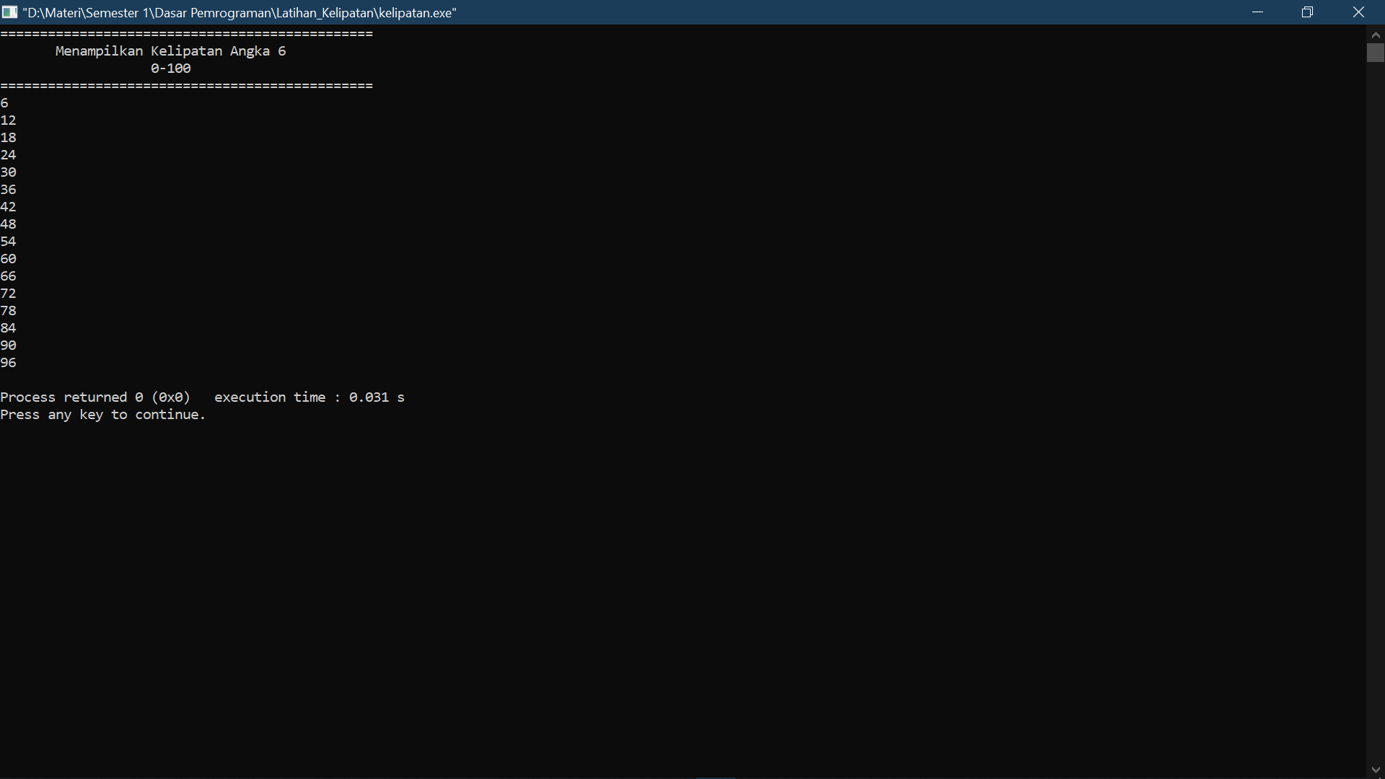

* Screenshot